**CH5 IT Infrastructure and Emerging Technologies**

學習目標 :

* 什麼是IT基礎架構及其組成部分？
* IT基礎架構發展的階段和技術驅動力是什麼？
* 計算機硬體平台的當前趨勢是什麼？
* 軟體平台目前的趨勢是什麼？
* 管理IT基礎設施的挑戰是什麼
* REFORMING THE REGULATORY SYSTEM FOR CONSTRUCTION PERMITS

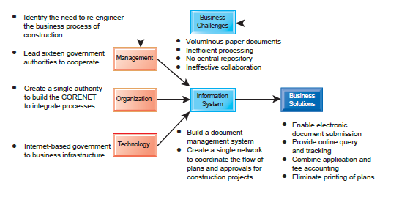

1. IT INFRASTRUCTURE
   * Preface

* A firm’s IT infrastructure provides the foundation for serving customers, working with vendors, and managing internal firm business processes

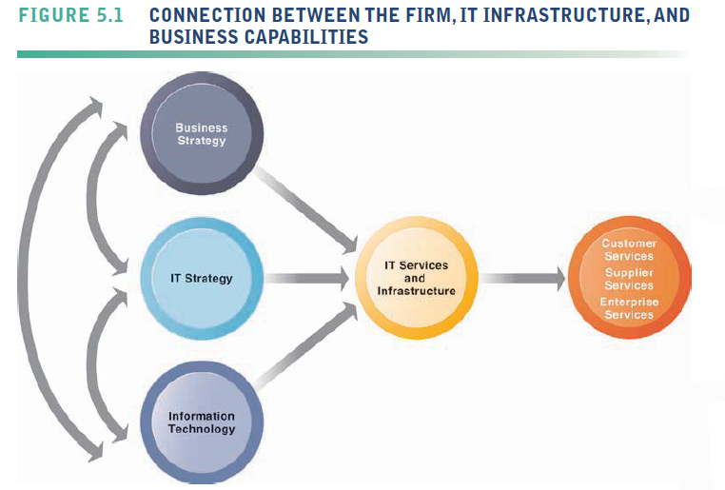

* + Defining IT Infrastructure
* a set of physical devices and software applications that are required to operate the entire enterprise.
* also a set of firmwide services budgeted by management and comprising both human and technical capabilities.These services include the following
* Computing platforms
  + - provide computing services that connect employees, customers, and suppliers into a coherent digital environment
* Telecommunications services
  + - provide data, voice, and video connectivity to employees, customers, and suppliers
* Data management services
  + - store and manage corporate data and provide capabilities for analyzing the data
* Application software services online software services
  + - provide enterprise-wide capabilities such as enterprise resource planning, customer relationship management, supply chain management, and knowledge management systems that are shared by all business units
* Physical facilities management services
  + - develop and manage the physical installations required for computing, telecommunications, and data management services
* IT management services
  + - plan and develop the infrastructure, coordinate with the business units for IT services, manage accounting for the IT expenditure, and provide project management services
* IT standards services
  + - provide the firm and its business units with policies that determine which information technology will be used, when, and how
* IT education services
  + - training in system use to employees and offer managers training in how to plan for and manage IT investments
* IT research and development services
  + - the firm with research on potential future IT projects and investments that could help the firm differentiate itself in the marketplace
  + Evolution of IT Infrastructure
* General-Purpose Mainframe and Minicomputer Era: (1959 to Present)
* Mainframe
  + - The introduction of the IBM 1401 and 7090 transistorized machines in 1959 marked the beginning of widespread commercial use of mainframe computers.
    - The mainframe era was a period of highly centralized computing under the control of professional programmers and systems operators (usually in a corporate data center)
    - Large-capacity, high-performance computer that can process large amounts of data very rapidly

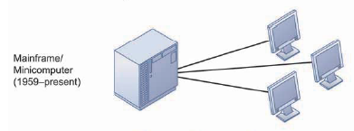

* Minicomputer
  + - powerful machines at far lower prices than IBM mainframes, making possible decentralized computing, customized to the specific needs of individual departments or business units rather than time sharing on a single huge mainframe
* Personal Computer Era: (1981 to Present)

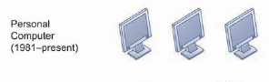

* Client/Server Era (1983 to Present)
* Form of distributed computing The client is the user point of entry
* Splits processing between “clients” and “servers”
* the server typically processes and stores shared data, serves up Web pages, or manages network activities.
* The term “server” refers to both the software application and the physical computer on which the network software runs.

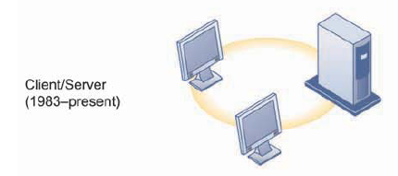

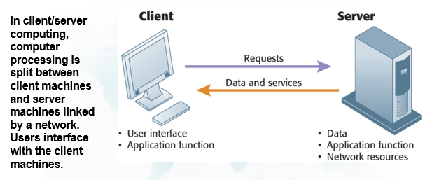

* Two-tiered client/server architecture
  + - Uses two types of machines
* multitiered (often called N-tier) client/ server architectures
  + - Balances load of network over several levels of servers
    - For example: Web servers and application servers

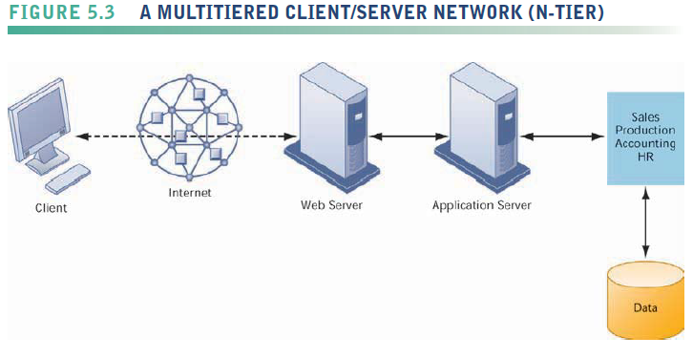

* Enterprise Computing Era (1992 to Present)
* links different pieces of computer hardware and smaller networks into an enterprise-wide network
  + - information can flow freely across the organization and between the firm and other organizations.
* The enterprise infrastructure also requires software to link disparate applications and enable data to flow freely among different parts of the business

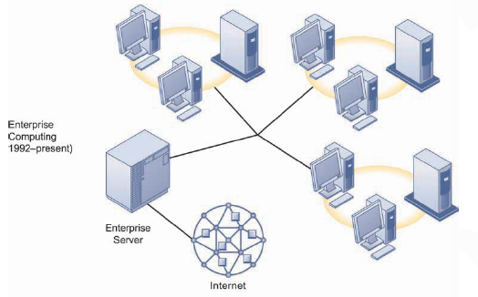

* Cloud and Mobile Computing Era (2000 to Present)
* Cloud computing
  + - a model of computing that provides access to a shared pool of computing resources (computers, storage, applications, and services) over a network, often the Internet.
    - These “clouds” of computing resources can be accessed on an as-needed basis from any connected device and location.
* Mobile Computing
  + - a technology that allows transmission of data, voice and video via a computer or any other wireless enabled device without having to be connected to a fixed physical link.
  + Technology Drivers of Infrastructure Evolution
* Moore’s Law and Microprocessing Power
* This law would later be interpreted in multiple ways.

There are at least three variations of Moore’s Law.

* + - the power of microprocessors doubles every 18 months
    - computing power doubles every 18 months
    - the price of computing falls by half every 18 months.

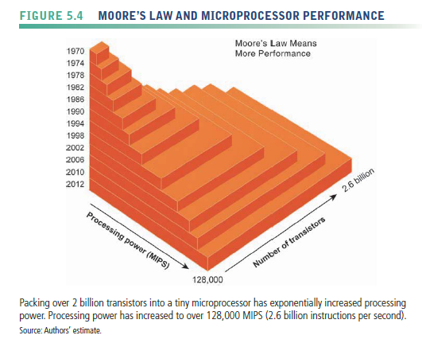

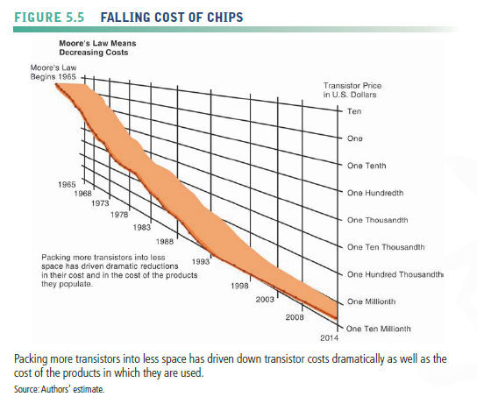

* Nanotechnology
  + - uses individual atoms and molecules to create computer chips and other devices that are thousands of times smaller than current technologies permit.



* The Law of Mass Digital Storage
* The amount of digital information is roughly doubling every year.
* the cost of storing digital information is falling at an exponential rate of 100 percent a year.

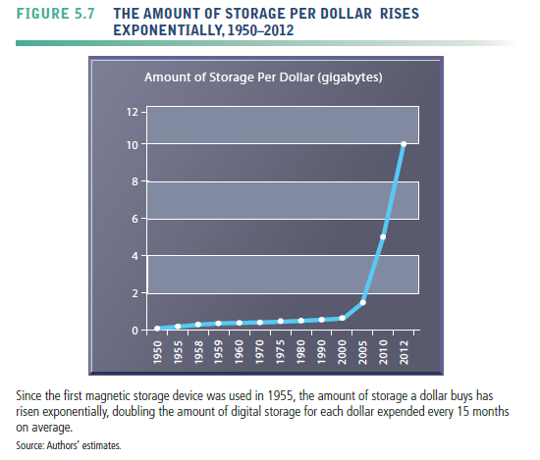

* Metcalfe’s Law and Network Economics
* Metcalfe and others point to the increasing returns to scale that network members receive as more and more people join the network.
* As the number of members in a network grows linearly, the value of the entire system grows exponentially and continues to grow forever as members increase.
* Declining Communications Costs and the Internet
* declining cost of communication both over the Internet and over telephone networks (which increasingly are based on the Internet)
* As communication costs fall toward a very small number and approach 0, utilization of communication and computing facilities explode

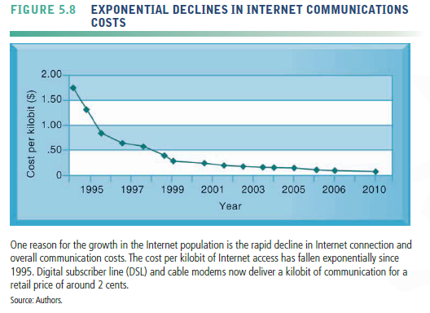

* Standards and Network Effects
* Technology standards are specifications that establish the compatibility of products and the ability to communicate in a network
* Technology standards unleash powerful economies of scale and result in price declines as manufacturers focus on the products built to a single standard

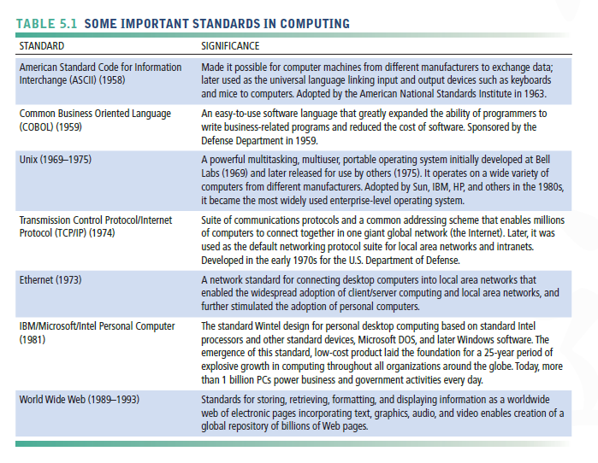

1. INFRASTRUCTURE COMPONENTS
   * Preface

* IT infrastructure today is composed of seven major components

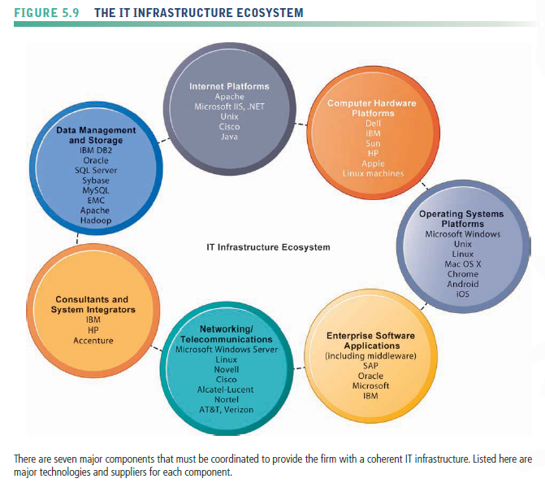

* + Computer Hardware Platforms
* The server market uses mostly Intel or AMD processors in the form of blade servers in racks, but also includes Sun SPARC microprocessors and IBM chips specially designed for server use.
* Blade servers
* computers consisting of a circuit board with processors, memory, and network connections that are stored in racks.
* Secondary storage
* may be provided by a hard drive in each blade server or by external mass-storage drives.
* Mainframes have not disappeared.
* be used to reliably and securely handle huge volumes of transactions, for analyzing very large quantities of data, and for handling large workloads in cloud computing centers.
  + Operating System Platforms
  + Enterprise Software Applications
* Microsoft Windows Server comprises about 35 percent of the server operating system market, with 65 percent of corporate servers using some form of the Unix operating system or Linux
* Unix and Linux
* scalable, reliable, and much less expensive than mainframe operating systems.
* can also run on many different types of processors
* the major providers of Unix operating systems
  + - IBM, HP, and Sun
* Google’s Chrome OS
* provides a lightweight operating system for cloud computing using netbooks.
* Android
* an open source operating system for mobile devices such as smartphones and tablet computers developed by the Open Handset Alliance led by Google.
* Conventional client operating system software is designed around the mouse and keyboard, but increasingly becoming more natural and intuitive by using touch technology.
* Apple iPad, iPhone, and iPod Touch
* Windows 8
  + ENTERPRISE SOFTWARE APPLICATIONS
* The largest providers of enterprise application software are SAP and Oracle
* middleware software supplied by vendors such as IBM and Oracle for achieving firmwide integration by linking the firm’s existing application systems.
* Microsoft is attempting to move into the lower ends of this market by focusing on small and medium sized businesses.
  + Data Management and Storage
* Enterprise database management software
* responsible for organizing and managing the firm’s data so that they can be efficiently accessed and used.
  + - IBM (DB2), Oracle, Microsoft (SQL Server), and Sybase (Adaptive Server Enterprise)
* MySQL is a Linux open source relational database
* Apache Hadoop is an open source software framework for managing massive data sets
* The physical data storage market is dominated by EMC Corporation for large-scale systems
* a small number of PC hard disk manufacturers led by Seagate and Western Digital.
* Storage area networks (SANs)
* connect multiple storage devices on a separate high-speed network dedicated to storage

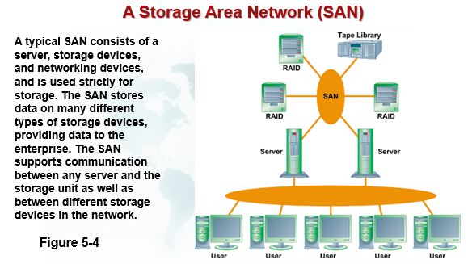

* + Networking/Telecommunications Platforms
* Most local area networks, as well as wide area enterprise networks, use the TCP/IP protocol suite as a standard
* The leading networking hardware providers
* Cisco, Alcatel-Lucent, Nortel, and Juniper Networks.
* Telecommunications platforms
* telecommunications/telephone services companies that offer voice and data connectivity, wide area networking, wireless services, and Internet access.
  + - AT&T and Verizon.
  + Internet Platforms
* Internet platforms overlap with, and must relate to, the firm’s general networking infrastructure and hardware and software platforms
* include hardware, software, and management services to support a firm’s Web site, including Web hosting services, routers, and cabling or wireless equipment.
* Web hosting service
* maintains a large Web server, or series of servers, and provides fee-paying subscribers with space to maintain their Web sites.
* server consolidation
* reducing the number of server computers by increasing the size and power of each and by using software tools that make it possible to run more applications on a single server.
  + - IBM, Dell, and Sun (Oracle), and HP,
* The major Web software application development tools and suites
* supplied by Microsoft (Microsoft Expression Studio and the Microsoft .NET family of development tools)
* Oracle-Sun (Sun’s Java is the most widely used tool for developing interactive Web applications on both the server and client sides)
  + Consulting and System Integration Services
* Consulting
* Implementing a new infrastructure requires significant changes in business processes and procedures, training and education, and software integration.
* Leading consulting firms providing this expertise
  + - Accenture, IBM Global Services, HP, Infosys, and Wipro Technologies
* Software integration
* ensuring the new infrastructure works with the firm’s older, so-called legacy systems and ensuring the new elements of the infrastructure work with one another.
* Replacing legacy systems is cost prohibitive and generally not necessary if these older systems can be integrated into a contemporary infrastructure.

1. CONTEMPORARY HARDWARE PLATFORM TRENDS
   * The Mobile Digital Platform

* Mobile devices, smartphone
* iPhone, Android
* transmission of data, surfing the Web, transmitting e-mail and instant messages, displaying digital content, and exchanging data with internal corporate systems.
* Netbooks and tablet computers
* iPad
* E-book readers
* Kindle
  + Consumerization of IT and BYOD
* bring your own device (BYOD)
* allowing employees to use their personal mobile devices in the workplace
* one aspect of the consumerization of IT
* Consumerization of IT
* includes not only mobile personal devices but also business uses of software services
  + - Google and Yahoo search, Gmail, Google Apps, Dropbox
* New technology that emerges in consumer market spreads into business organizations
  + - Facebook, twitter
* forcing businesses, especially large enterprises, to rethink the way they obtain and manage information technology equipment and services
  + Grid Computing
* connecting geographically remote computers into a single network to create a virtual supercomputer by combining the computational power of all computers on the grid
* advantage
* leaving idle resources available for other processing tasks.
* cost savings, speed of computation, and agility.
* requires software programs to control and allocate resources on the grid.
  + Virtualization
* the process of presenting a set of computing resources (such as computing power or data storage) so that they can all be accessed in ways that are not restricted by physical configuration or geographic location.
* enables a single physical resource (such as a server or a storage device) to appear to the user as multiple logical resources.
* Enables companies to host multiple systems on single machine
* helps organizations increase equipment utilization rates, conserving data center space and energy usage.
* also enables multiple physical resources (such as storage devices or servers) to appear as a single logical resource, as would be the case with storage area networks or grid computing.
* facilitates centralization and consolidation of hardware administration
  + Cloud Computing
* a model of computing in which computer processing, storage, software, and other services are provided as a pool of virtualized resources over a network, primarily the Internet.

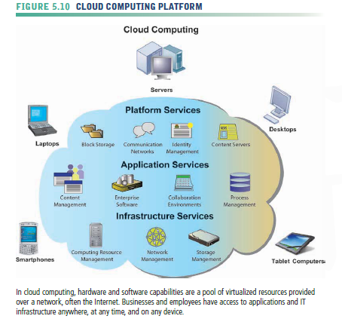

* The U.S. National Institute of Standards and Technology (NIST) defines cloud computing as having the following essential characteristics (Mell and Grance, 2009):
* On-demand self-service
  + - Consumers can obtain computing capabilities needed automatically on their own.
* Ubiquitous network access
  + - Cloud resources can be accessed using standard network and Internet devices, including mobile platforms.
* Location-independent resource pooling
  + - Computing resources are pooled to serve multiple users, with different virtual resources dynamically assigned according to user demand. The user generally does not know where the computing resources are located.
* Rapid elasticity
  + - Computing resources can be rapidly provisioned, increased, or decreased to meet changing user demand.
* Measured service
  + - Charges for cloud resources are based on amount of resources actually used.
* Cloud computing consists of three different types of services:
* Cloud infrastructure as a service
  + - Customers use processing, storage, networking, and other computing resources from cloud service providers to run their information systems
    - Amazon uses the spare capacity of its IT infrastructure to provide a broadly based cloud environment selling IT infrastructure services.
* Cloud platform as a service
  + - Customers use infrastructure and programming tools supported by the cloud service provider to develop their own applications.
    - BM offers a Smart Business Application Development & Test service for software development and testing on the IBM Cloud.
* Cloud software as a service
  + - Customers use software hosted by the vendor on the vendor’s cloud infrastructure and delivered over a network.
    - Google Apps, which provides common business applications online

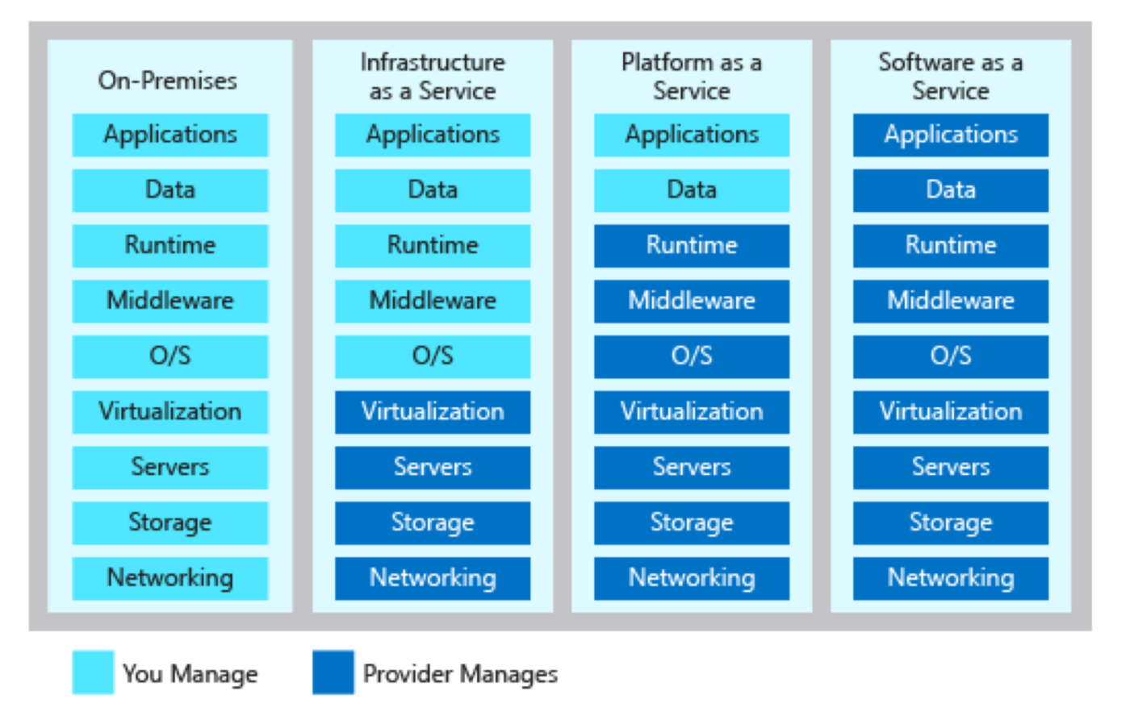

* public cloud & private cloud
* public cloud
  + - owned and maintained by a cloud service provider, such as Amazon Web Services, and made available to the general public or industry group
* private cloud
  + - operated solely for an organization, It may be managed by the organization or a third party and may exist on premise or off premise.
* Drawbacks
  + - the responsibility for data storage and control is in the hands of the provider
    - security risks related to entrusting their critical data and systems to an outside vendor that also works with other companies.
* hybrid cloud
* Large firms are most likely to adopt it.
* Large firms use their own infrastructure for their most essential core activities and adopt public cloud computing for less critical systems or for additional processing capacity during peak business periods
  + Green Computing
* By curbing hardware proliferation and power consumption, virtualization has become one of the principal technologies for promoting green computing.
* practices and technologies for designing, manufacturing, using, and disposing of computers, servers, and associated devices to minimize the impact on the environment.
  + High-Performance and Power-Saving Processors
* Another way to reduce power requirements and hardware sprawl
* use more efficient and power-saving processors.
* A multicore processor
* an integrated circuit to which two or more processor cores have been attached for enhanced performance, reduced power consumption, and more efficient simultaneous processing of multiple tasks.
  + Autonomic Computing
* an industry-wide effort to develop systems that can configure themselves, optimize and tune themselves, heal themselves when broken, and protect themselves from outside intruders and self-destruction.

1. CONTEMPORARY SOFTWARE PLATFORM TRENDS
   * Linux and Open Source Software

* Open source
* produced by a community of several hundred thousand programmers around the world
* free and can be modified by users.
* Works derived from the original code must also be free
* the software can be redistributed by the user without additional licensing.
* Popular open source software tools
  + - Linux operating system, the Apache HTTP Web server, the Mozilla Firefox Web browser, and the Apache OpenOffice desktop productivity suite
* cost reduction, reliability and resilience, and integration
* Linux
* an operating system related to Unix.
* a major force in local area networks, Web servers, and high-performance computing work
  + Software for the Web: Java, HTML, and HTML5
* Java
* an operating system-independent, processor independent, object-oriented programming language, the leading interactive environment for the Web
* Java software is designed to run on any computer or computing device, regardless of the specific microprocessor or operating system the device uses.
* Java developers can create small applet programs that can be embedded in Web pages and downloaded to run on a Web browse
* At the enterprise level, Java is being used for more complex e-commerce and e-business applications that require communication with an organization’s back-end transaction processing systems.
* HTML
* HTML (Hypertext Markup Language) is a page description language for specifying how text, graphics, video, and sound are placed on a Web page and for creating dynamic links to other Web pages and objects
* Third-party plug-in applications like Flash, Silverlight, and Java have been required to integrate these rich media with Web pages
* HTML5
* Next evolution of HTML
* Enables multimedia embedding without 3rd party add-ons such as Flash
  + Web Services and Service-Oriented Architecture
* Web Services
* a set of loosely coupled software components that exchange information with each other using universal Web communication standards and languages.
* build open standard Web-based applications linking systems of two different organizations
* create applications that link disparate systems within a single company.
* not tied to any one operating system or programming language
* XML
* Extensible Markup Language
* The foundation technology for Web services
* perform presentation, communication, and storage of data

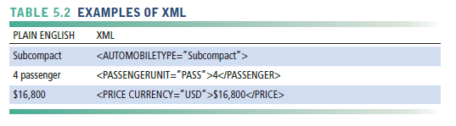

* makes it possible for computers to manipulate and interpret their data automatically and perform operations on the data without human intervention.
* provides a standard format for data exchange, enabling Web services to pass data from one process to another.
* Service oriented architecture (SOA)
* The collection of Web services that are used to build a firm’s software systems constitutes
* set of self-contained services that communicate with each other to create a working software application.

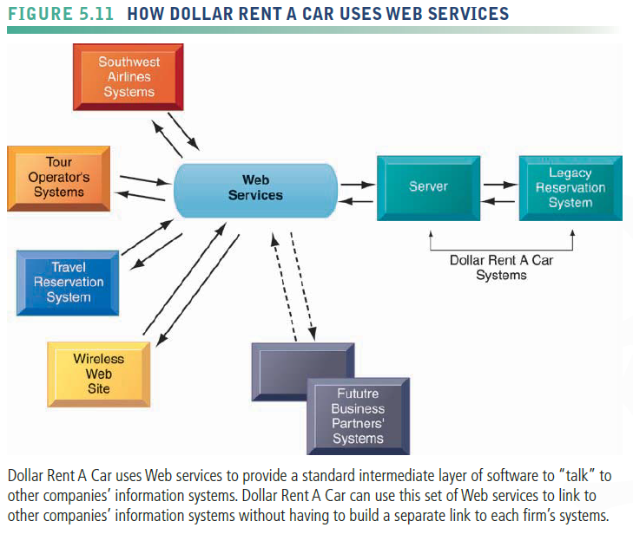

* + Software Outsourcing and Cloud Services
* the rapid growth in external sources of software for U.S. firms

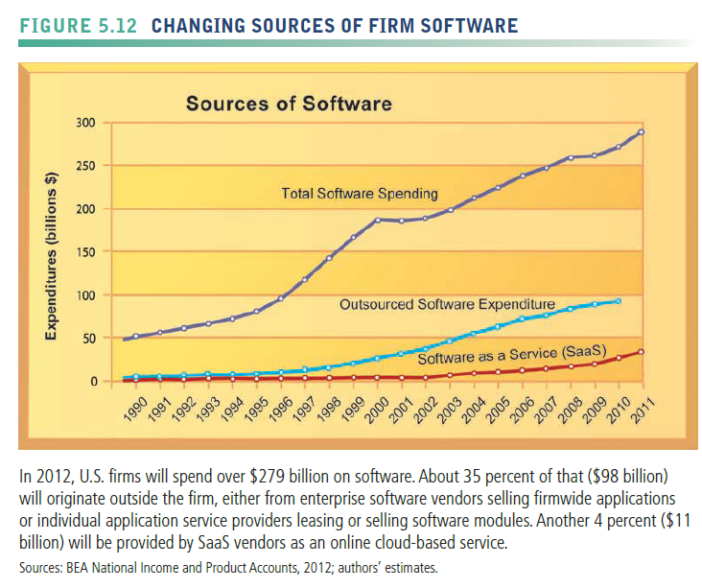

* Software Packages and Enterprise Software
* a prewritten commercially available set of software programs that eliminates the need for a firm to write its own software programs for certain functions
* SAP and Oracle-PeopleSoft
* Software Outsourcing
* enables a firm to contract custom software development or maintenance of existing legacy programs to outside firms, which often operate offshore in low-wage areas of the world.
* Cloud-Based Software Services and Tools
* hosted on powerful servers in massive data centers, and can be accessed with an Internet connection and standard Web browser.
* Web-based service are now referred to as software as a service (SaaS)
  + - Google docs
* Service level agreement (SLA)
  + - a formal contract between customers and their service providers that defines the specific responsibilities of the service provider and the level of service expected by the customer.
    - a formal contract between customers and their service providers that defines the specific responsibilities of the service provider and the level of service expected by the customer.
* Mashups and Apps
* mashups.
  + - Individual users and entire companies mix and match these software components to create their own customized applications and to share information with others.
    - Web mashups combine the capabilities of two or more online applications to create a kind of hybrid that provides more customer value than the original sources alone.
* Apps
  + - small pieces of software that run on the Internet, on your computer, or on your mobile phone or tablet and are generally delivered over the Internet.
    - Google refers to its online services as apps, including the Google Apps suite of desktop productivity tools.

1. MANAGEMENT ISSUES
   * Dealing with Platform and Infrastructure Change

* Scalability
* the ability of a computer, product, or system to expand to serve a large number of users without breaking down.
* New applications, mergers and acquisitions, and changes in business volume all impact computer workload and must be considered when planning hardware capacity.
* It is up to business management to determine acceptable levels of computer response time and availability for the firm’s mission-critical systems to maintain the level of business performance they expect.
  + Management and Governance
* A long-standing issue among information system managers and CEOs has been the question of who will control and manage the firm’s IT infrastructure.
* Should departments and divisions have the responsibility of making their own information technology decisions or should IT infrastructure be centrally controlled and managed?
* What is the relationship between central information systems management and business unit information systems management?
* How will infrastructure costs be allocated among business units?
  + Making Wise Infrastructure Investments
* rent-versusbuy decision
* The decision either to purchase your own IT assets or rent them from external providers
* Total Cost of Ownership of Technology Assets
* The actual cost of owning technology resources
  + - original cost of acquiring and installing hardware and software
    - ongoing administration costs for hardware and software upgrades, maintenance, technical support, training, and even utility
    - real estate costs for running and housing the technology
* The total cost of ownership (TCO) model
  + - 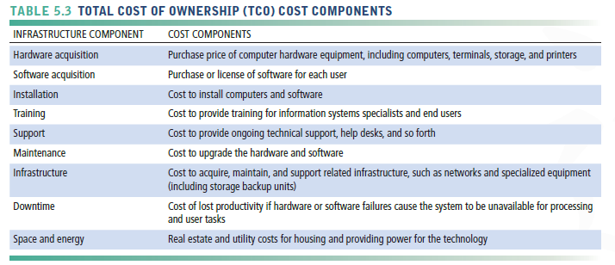analyze these direct and indirect costs to help firms determine the actual cost of specific technology implementations.
    - When all these cost components are considered, the TCO for a PC might run up to three times the original purchase price of the equipment.
    - Gains in productivity and efficiency from equipping employees with mobile computing devices must be balanced against increased costs from integrating these devices into the firm’s IT infrastructure and from providing technical support.
    - Many large firms are saddled with redundant, incompatible hardware and software because their departments and divisions have been allowed to make their own technology purchases
    - In addition to switching to cloud services, these firms could reduce their TCO through greater centralization and standardization of their hardware and software resources.
* Competitive Forces Model for IT Infrastructure Investment
* a competitive forces model you can use to address the question of how much your firm should spend on IT infrastructure.

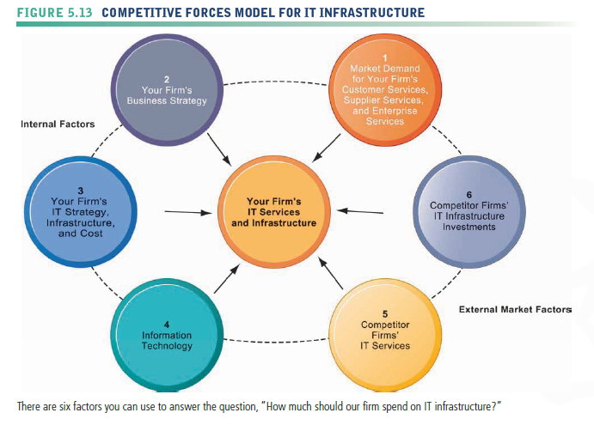

* Market demand for your firm’s services.
  + - Make an inventory of the services you currently provide to customers, suppliers, and employees.
    - Survey each group, or hold focus groups to find out if the services you currently offer are meeting the needs of each group.
* Your firm’s business strategy
  + - Analyze your firm’s five-year business strategy and try to assess what new services and capabilities will be required to achieve strategic goals.
* Your firm’s IT strategy, infrastructure, and cost
  + - Examine your firm’s information technology plans for the next five years and assess its alignment with the firm’s business plans
    - Determine the total IT infrastructure costs
* Information technology assessment.
  + - Is your firm behind the technology curve or at the bleeding edge of information technology? Both situations are to be avoided.
* Competitor firm services
  + - Try to assess what technology services competitors offer to customers, suppliers, and employees.
* Competitor firm IT infrastructure investments.
  + - Benchmark your expenditures for IT infrastructure against your competitors.